**Experiment 3 DEC LAB**

**29.09.2020**

**Aim**

To design circuits of full adder, full subtractor, half adder and half subtractor.

**Apparatus required**

1) Tinkercad Software for designing circuits

2) Breadboard

3) Power Supply

4) Slideswitch

5) IC of Logic gates

6) Resistor

7) Led bulb for signal

8) Connecting Wires

**Theory**

In digital circuits, adders and subtractors are the circuits which are able to perform binary addition and subtraction.

Half adders are combinational logic circuit which performs addition of two bits. It has two inputs A and B and two outputs Sum and Carry respectively.

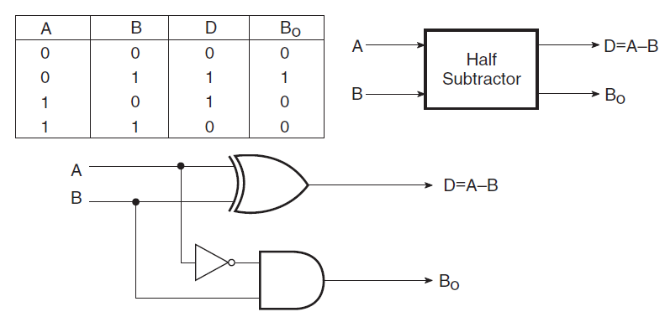

Full adders are combinational logic circuit which perform addition of three bits. It is also a combination of two half adders as well. It has three inputs A, B and Cin  and two outputs Sum and Cout respectively.

Half subtractor is a combinational logic circuit which performs binary subtraction of two bits. It has two inputs A and B and two outputs Difference and Borrow out BO.

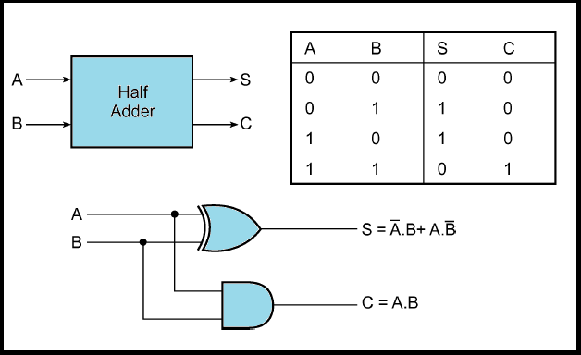

Full subtractor is a combinational logic circuit which performs binary subtraction of three bits. It is also a combination of two half subtractors. It has three inputs A,B and Bin and two outputs Difference(D) and Bout.

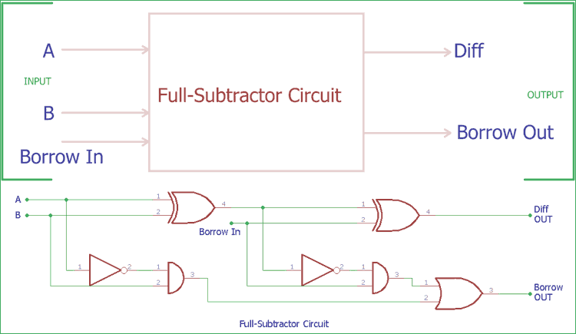

Their applications include arithmetic calculations in calculator, signal processing and in timers, program counters

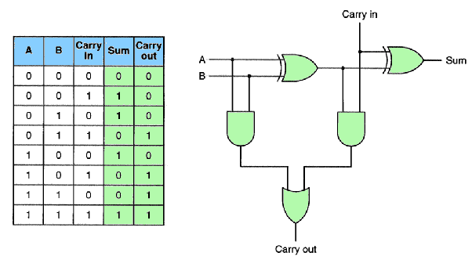

**Observation**

Half adder circuit

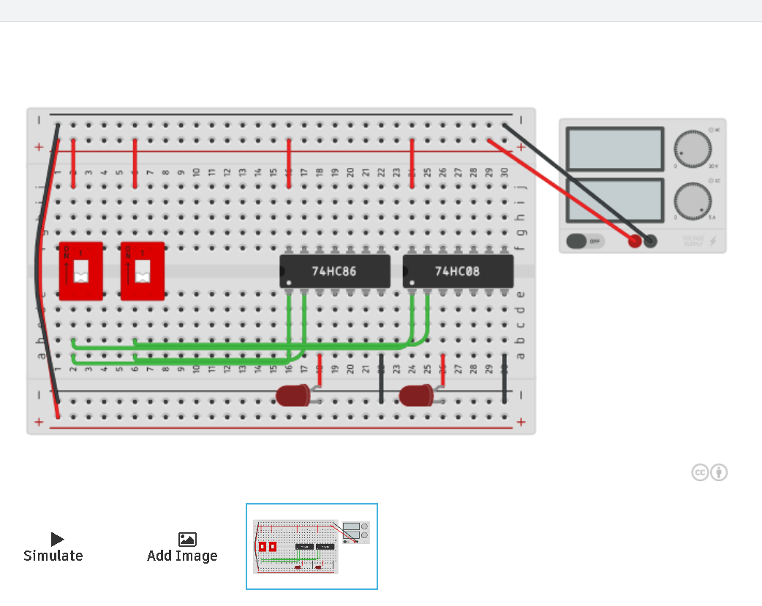

Full adder circuit

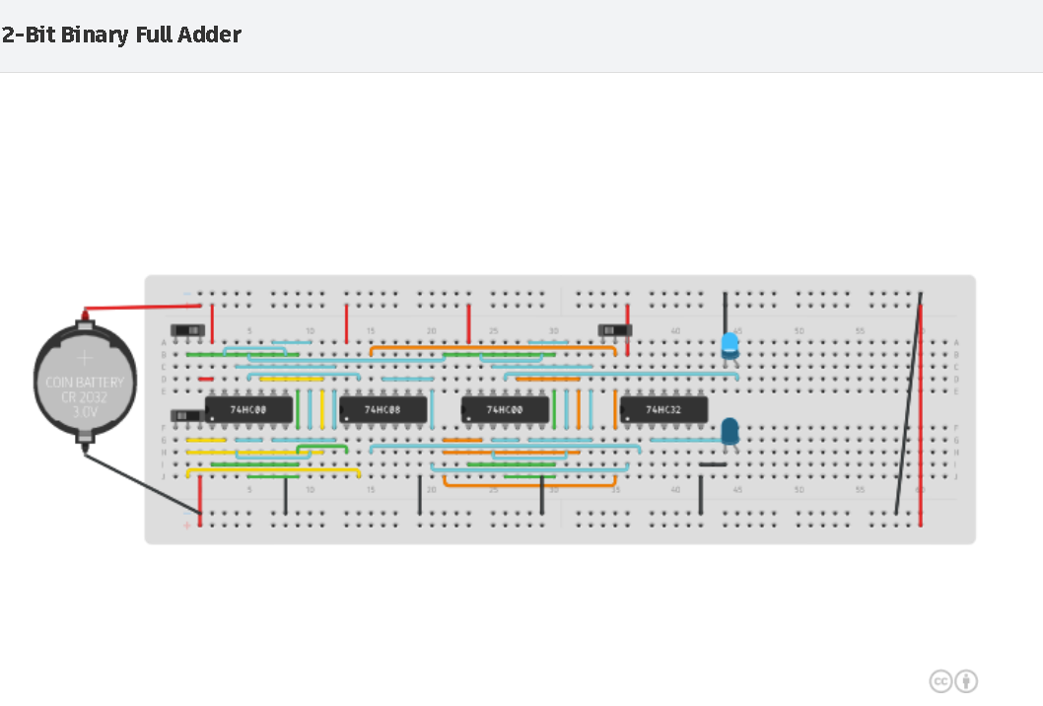

Half subtractor circuit

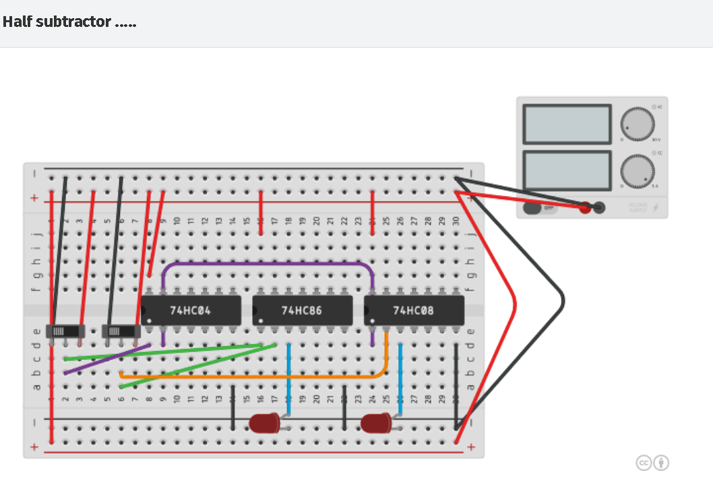

­Full subtractor circuit

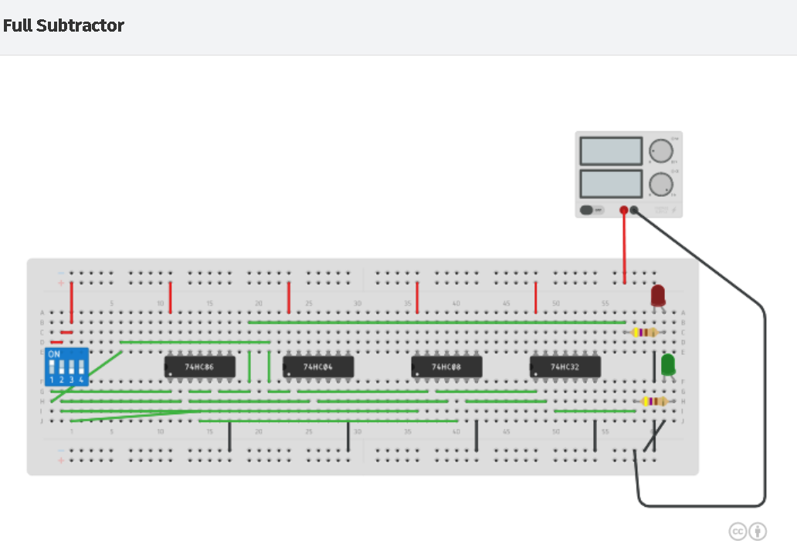

**Conclusion** All the circuits were designed and verified for all inputs.

**Name: Harsh Kumar**

**Branch: CE-3rd Semester**

**ID- B219027**